Geometry: Unit 7, Lesson 1

- What is the expression $8^{2}+7^{2}$ equivalent to?

$$113$$

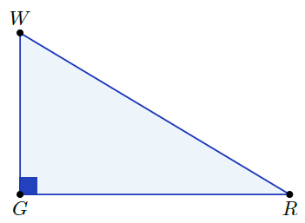
- $∆RWG$ where $m∠WGR=90°$ is shown. Is the statement ${\left(RW\right)}^{2}+{\left(GW\right)}^{2}={\left(RG\right)}^{2}$ true?

No

- Is the equation ${36}^{2}+{77}^{2}={85}^{2}$ true?

Yes

